**Feedback 2 to Qudos**

**\* Frame 1 and 2** – fine

**\* Frame 3** – Please can we clarify what’s to replace this frame?

We just wanted the big “No!” drawn on as in the feedback to emphasis the script – it was not a comment on the slide itself!

**\* Frame 4 and 5**, and wherever we show predicted ranges. Use the colour #566af9 for the predicted range to agree with what we have on the web site. Use a light shade of this same blue for the extended predicted range when we show that (frame 18).

**\* Frame 6 and 7**, are fine.

**\* Frame 8** - Should we see the text over the drawings as per the drawing on the feedback?

Yes, but use example percentages and label the risk categories – eg 85% chance of survival (higher risk), 99% chance of survival (lower risk), 95% chance of survival (medium risk)

I’d suggest drawing one after the other to avoid clutter – one drawing for each risk level. And use the

final icon colours for low, medium and high risks.

**\* Frame 9 (prev. frame 10)** – Are these the exact numbers that appear on the feedback?

The predicted ranges should be stacked so we can see visually that one is to the left (lower range) than the other as per last feedback. They should both be drawn on the same axis (eg axis in 16). Numbers as on last feedback.

i.e. hospital 1: 94% - 97% hospital 2: 95% - 99% Bar colour should be #566af9

We’ll carry hospital 1 through into frames 10 onwards, so make it have 100 icons. Use 50 icons for Hospital 2.

**Hospital 1** icon array should look like this

(Using **sample = 13** at http://understandinguncertainty.org/files/animations/for-qudos/index.html)

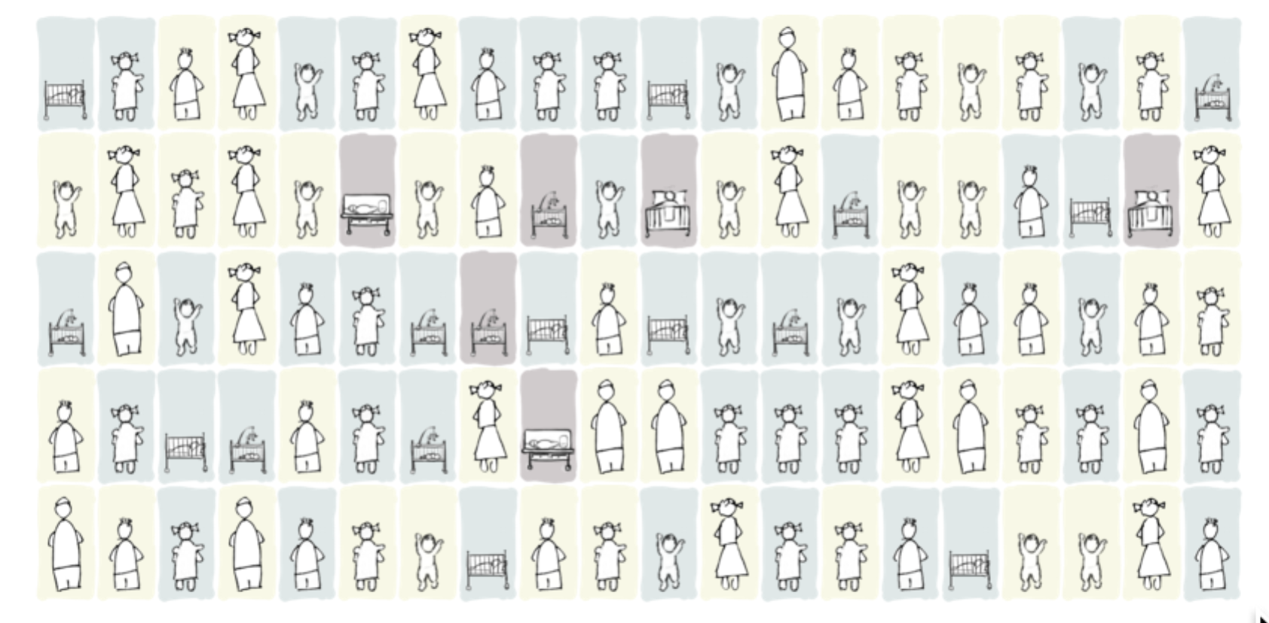

**Hospital 2** icon array should look like this:

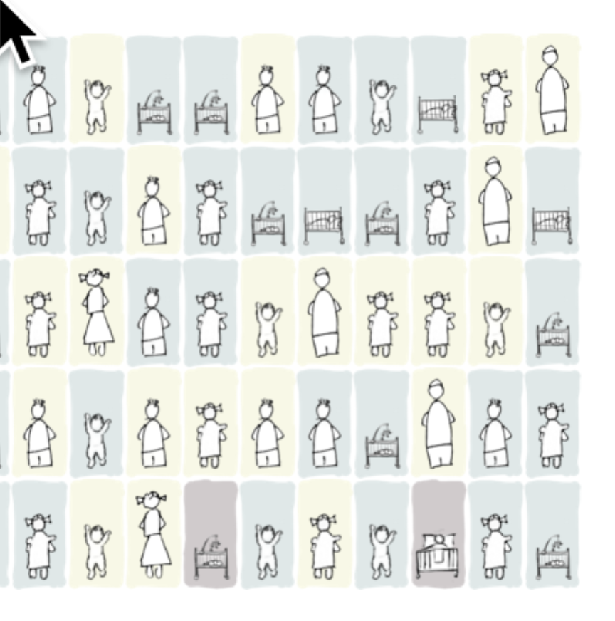

It’s the right hand side of **sample 29**.

**\* Frame 10 (prev. frame 11)** - should we remove all the shading here? Yes. Use Hospital 1 array **without** the shading. Add a graphic (echoing slide 8) showing the formula being applied to transition slide 10 to slide 11.

**\* Frames 11 to 16.**  Base these on the Hospital 1 array (see above). The base array should not change – it’s always the same set of operations which is easier to grasp if it stays constant. Choose a nice layout with space for one icon array, the percentage survival and the chart of possible futures, and stick with it. We like the big 98% in slide 13.

When showing deaths, transition the icon through the darker background/ghosted image to the ghost drawing on the original background (i.e. the drawing with white fills, but no black lines).

**\* Frame 16.**

Use <http://understandinguncertainty.org/files/animations/for-qudos/index.html> to generate the charts for frames 0 to 20. (We’ve decided to look at 20 possible outcomes rather than 60 so people don’t have to do the mental arithmetic to convert 3 in 60 to 1 in 20.) The parameters should be:

Sample: 13

Deaths: 4.5

Skew% 10

Spread 0.75

Future seed 19

Then step the frame from 0 to 20.

**The charts should use rectangular tally marks rather than black dots, but not in blue or black**. **Whatever you choose has to then also replace the black dots in frames 13-15**. It’s currently using the second colour in d3 category 10. See <http://bl.ocks.org/aaizemberg/78bd3dade9593896a59d>

**\* Frame 17**

Use the **hospital 1** drawing with these parameters (again)

Sample: 13

Deaths: 4.5

Skew% 10

Spread 0.75

Frame 20

Future seed 19 to generate:

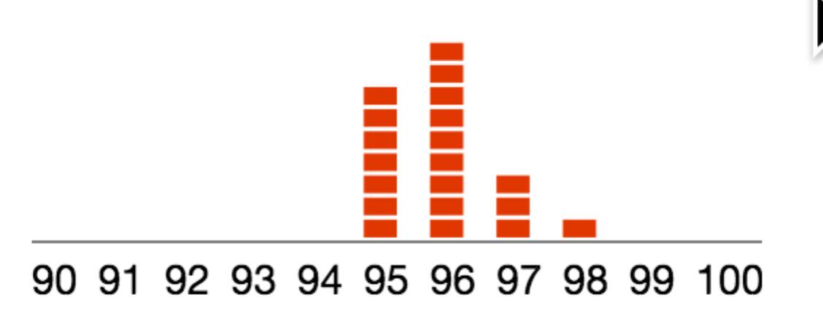

Make a predicted range bar of 94% to 97%.

**\* Frame 18**

Use the **hospital 1 drawing** with the these parameters, ramping the frame up to 1000 to generate:

Sample: 13

Deaths 4.5

Skew%: 10

Spread: 0.97

Frame: 1000:

Future seed 100 to generate:

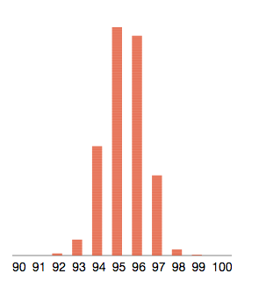

Make an extended predicted range bar of 93% to 98% with the predicted range 94% to 97% overlaid.

Slide 17 predicted range should be **94% to 97%**

**\* Frame 19.**

hospital 1, on the left should have the long line of children and the shorter range

Use the hospital 1 drawing with these parameters (again)

Sample: 13

Deaths: 4.5

Skew% 10

Spread 0.75

Frame 20

Future seed 19 to generate:



Draw the predicted range from **94% to 97% over the extended predicted range** of 93% to 98%.

Hospital 3 has the shorter line of children.

(NOTE: hospital 3 – the ranges are different from hospital 2)

Use a hospital 3 drawing with these parameters

Sample: 13

Deaths: 5

Skew% 10

Spread 1.6

Frame 20

Future seed 107 to generate:

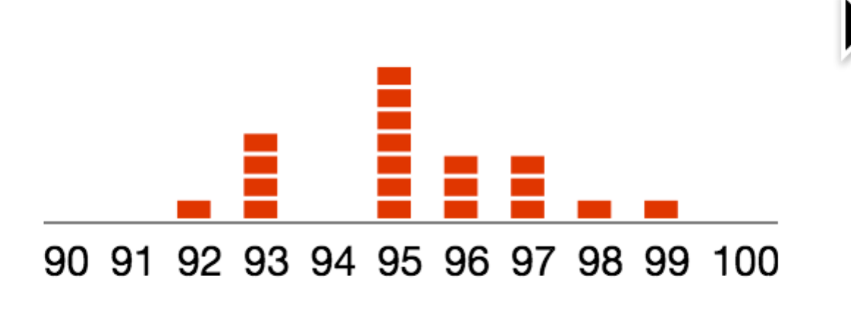

Draw the predicted range from 92% to 98% over an extended predicted range of 90% to 100%.

**\* Transition to Frame 20**

We’re now going back to comparing our original two hospitals, so it might be good to transition quickly through a repeat of frame 1 into frame 20. **Hospital 1, with the longer line of children should be on the left.**

Use these parameters for hospital 1:

**\* Frame 20 to 22**

hospital 1, on the left should have the usual 100 icons

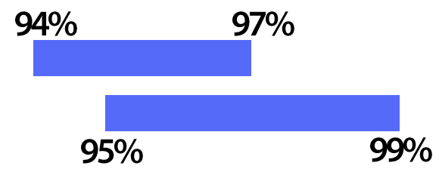The predicted range should be 94% to 97%

hospital 2, on the right should have its original 50 icons.

The predicted range should be 95% to 99%.

Stack these bars on the same axis with an overlap,

Hospital 1 over hospital 2.

**\* Frame 22**

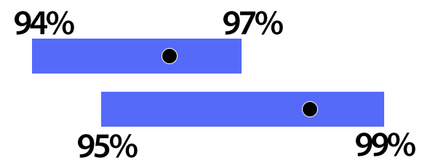Apply actual survival rates as dots using a black fill with a white 1px stroke at 96% for hospital 1 and 98% for hospital 2. Label the dots ‘Actual Survival Rate’.

to generate